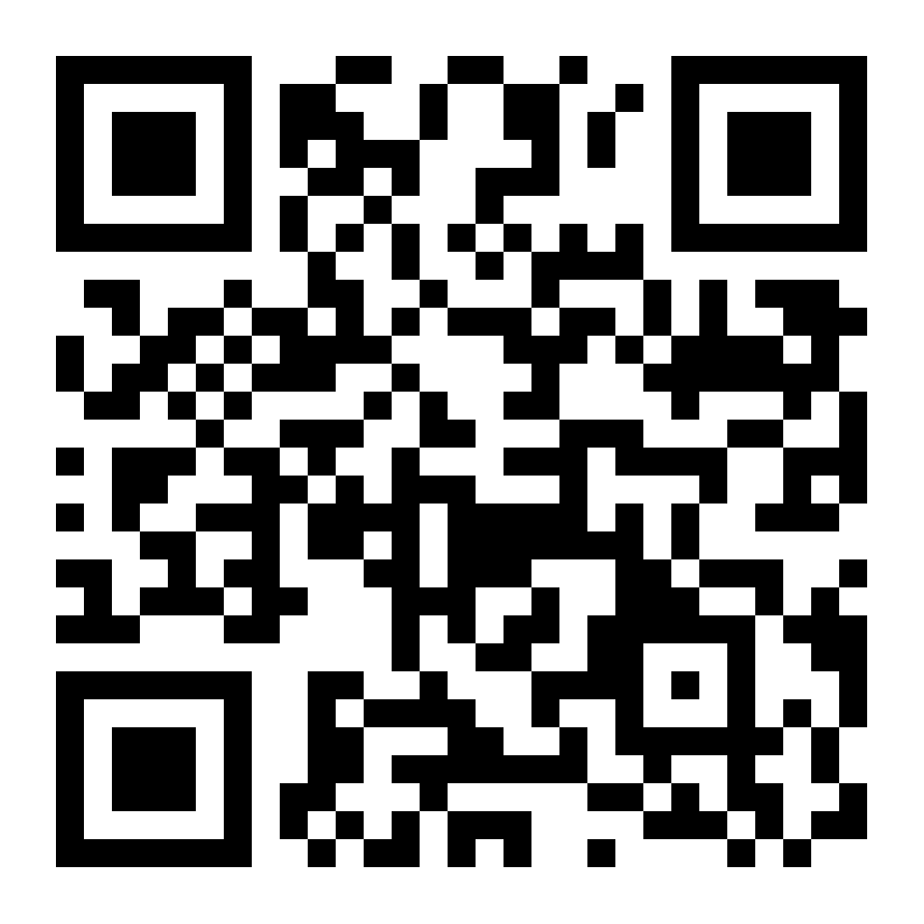
The 6th MSPS Annual Meeting
October 19, 2024
Andrew E. Lee Memorial Medicine & Science Building
University of South Dakota

Morning Session:
8:00 – 8:45 AM Registration/Breakfast
8:45 – 9:00 AM Welcome and Opening Remarks – Dr. Hong Zheng, USD

9:00 – 10:00 AM Keynote Presentation - Dr. Javier Stern, MD, PhD, Georgia State University, “Role of Neuropeptides in the Regulation of Neurovascular Coupling in the Hypothalamus: Physiological and Pathological Implications”

10:00 – 10:30 AM Local Faculty Presentation - Dr. Micah Schott, PhD, Nebraska Medical Center, “Fighting Fat - Lipid Droplet Trafficking in Liver Disease” (Session Chair: Dr. Sathish Natarajan, UNL)

10:30 – 10:45 AM Break and Poster Reviewing
10:45 – 12:00 AM Trainee Presentation Session-1: Session Chairs - Dr. Surabhi Chandra, UNK; Dr. Abazarikia, UNMC
10:45-11:05 AM Dr. Saima Ejaz, “Genetic blockade of PKA-mediated phosphoregulation of 26S proteasomes exacerbates pathology in both the brain and heart of an Alzheimer’s disease model”

11:05-11:25 AM SunYoung Kim, “Impact of co-existent maternal diabetes and otherwise non-deleterious genetic mutation on cardiac outflow tract development in mice”

11:25-11:45 AM Taija Hahka, “Resolvin D2 mitigates TNFα-induced mitochondrial reactive oxygen species via Nrf2 signaling in trophoblasts”

11:45-12:00 AM Zachary Venn, “Insights into the increased risk for chronic kidney disease in people living with HIV: role of the glycolysis and inflammation-induced byproduct, methylglyoxal”

Afternoon Session:
12:00 – 12:30 PM Lunch break
12:30 – 1:40 PM Poster presentation I (Odd number)
1:40 – 2:50 PM Poster presentation II (Even number)

2:50 – 3:30 PM Trainee Presentation Session-2: Session Chairs - Dr. William Chen, USD; Flobater Gawargi, UNMC
2:50-3:10 PM Dr. Wonmi So “Alkylating agents deplete primordial follicles and disrupt ovarian vasculature independently in mice”

3:10-3:30 PM Rachael Urquhart, “Global ischemia induced neurodegeneration and cognitive deficits are alleviated following TREM1 inhibition”

3:30 – 4:00 PM Local Faculty Presentation - Dr. Brian North, PhD, Creighton University “Regulation of Organ Development and Disease by BubR1” (Session Chair: Dr. So-Youn Kim, UNMC)

4:00 – 4:30 PM Award Announcement and Closing Remarks
4:30 PM Adjourn

